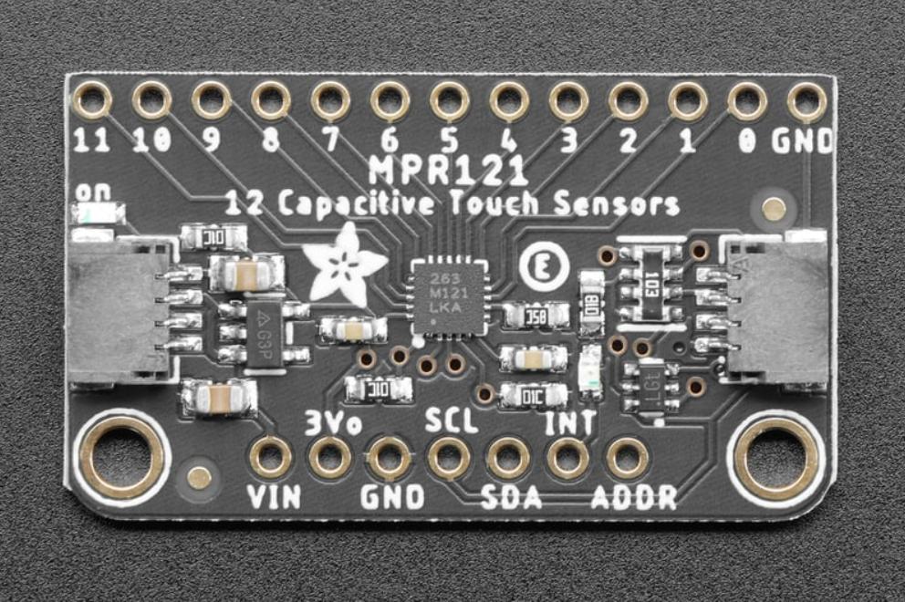

Figure 1: Adafruit MPR121 12-Key Capacitive Touch Sensor Breakout is used in E-Remote. The MPR121 has 12 sensor pins that will replace push buttons in the initial hardware.

Table 2: Results of Adafruit MPR121 Sensor Material Conductivity Testing. The purpose of this test was to determine the material(s) that could be used as touch sensor pads of E-Remote.

| **Material** | **Conductive? Y/N** |
| --- | --- |
| Plastic bag | N |
| Surgical Glove | Y |
| Cloth | N |
| Aluminum Metal | Y |
| 3D printer plastic filament | N |
| Paper | N |
| Plastic | N |
| Metal clip | Y |

It is concluded that we need a conductive material for the touch sensor pads. Aluminum or steel metal sheets would work best for our design. The metal sheet would have laser cut holes so that LED light can shine through. The metal sensor would be protected with a conductive plastic film.

Touch Sensor Placement

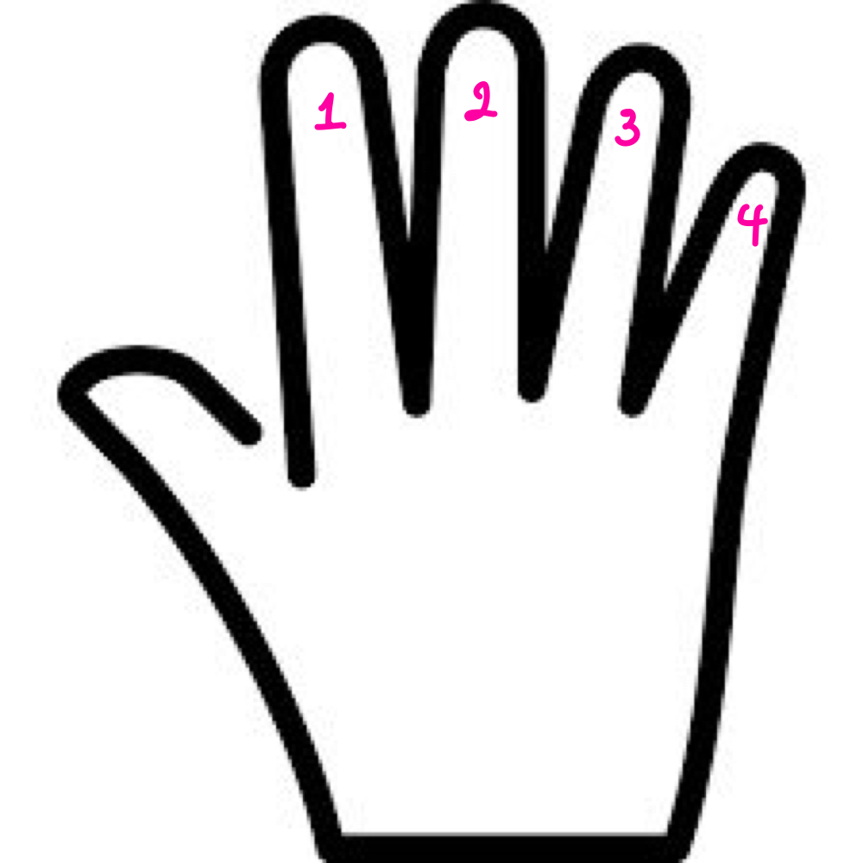

Figure 1: Right hand fingers to touch sensor button assignment

| Button # | Length/Width/Distance from Joystick | Revision:  Length/Width/Distance from Joystick |
| --- | --- | --- |
| Button 1 | 2.50/0.95/0 |  |
| Button 2 | 1.23/0.7/0.8 |  |
| Button 3 | 1.23/0.7/0.8 |  |
| Button 4 | 2.50/0.7/0 |  |

Feedback:

* Interchangeable joystick mount sizes to fit user’s hand size
* Buttons should be longer/ increase controller width by one or two centimeters
* Decrease controller height